# Scenario 1

Scenario Description: This scenario demonstrates the creation of both the baseline and final .bak files requested.

Scenario Screen Captures of Output:





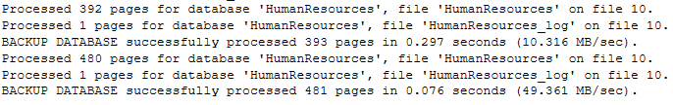

# Scenario 2

Scenario Description: This scenario demonstrates how a new employee is created, with the create date/by populated, and the modify date/by are not populated.

Scenario Screen Capture of Output: **Indicated by lines 5, and 8.**

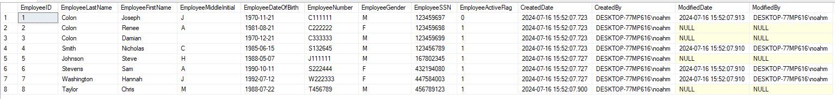

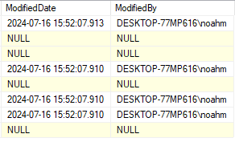

# Scenario 3

Scenario Description: This scenario demonstrates an employee updated with the modify date/by populated.

Scenario Screen Capture of Output: **Indicated by lines 4, 6, and 7.**





# Scenario 4

Scenario Description: This scenario demonstrates that the create date is not changed after the employee record is updated.

Scenario Screen Capture of Output: **Indicated by the fact that all entries between the CreatedDate and the ModifiedDate are different, and that all ModifiedDate entries were written after the CreatedDate entries.**

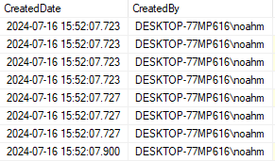



# Scenario 5

Scenario Description: This scenario demonstrates that deleting an employee is not a physical deletion, but a logical one.

Scenario Screen Capture of Output: **Specified by lines 5 and 6, showing the modification of and then deletion of employee record 1, by name of Joseph Colon.**

Employee History Table:



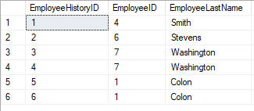

Employee Table:

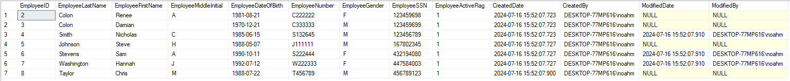

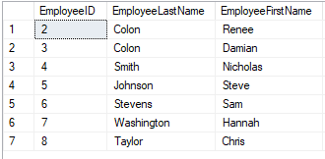

# Scenario 6

Scenario Description: This scenario demonstrates that employee history is populated as an employee record as CRUD operations are performed using CRUD stored procedures. This must be shown for at least 3 different employee records.

Scenario Screen Capture of Output: **Indicated by lines 1, 2, 3, and 4 of the Employee History Table, showing the edit history for employees Nicholas Smith, Sam Stevens, and Hannah Washington**



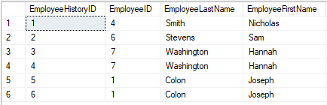

# Scenario 7

Scenario Description: This scenario demonstrates the result of multiple updates on the same employee record.

Scenario Screen Capture of Output: **Indicated by lines 3 and 4 of the Employee History table,**



